**Question 1**

On the 16th of September, Will sent a batch of 25 SMS’s. The reason for this could be that he had to send messages to people and did not have any data connection and had to use SMS.

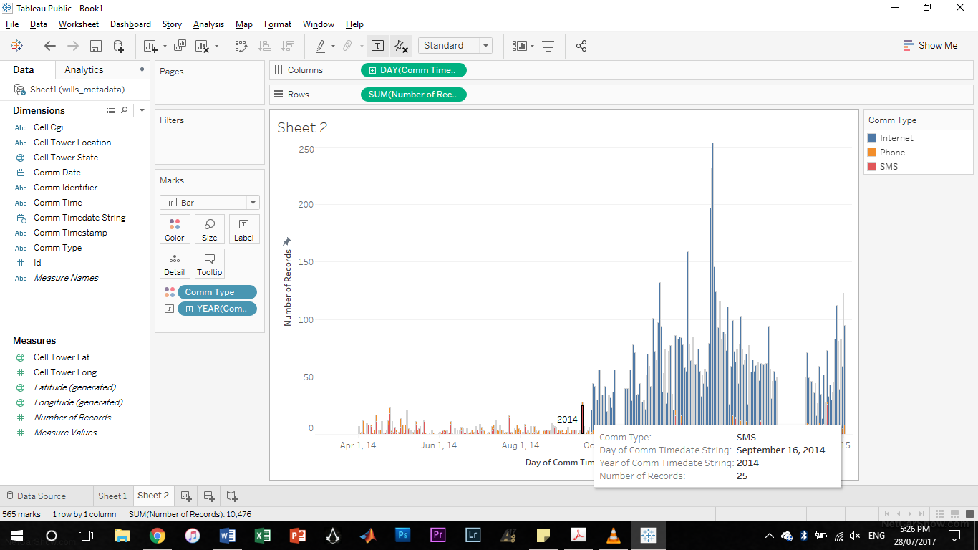

**Question 2**

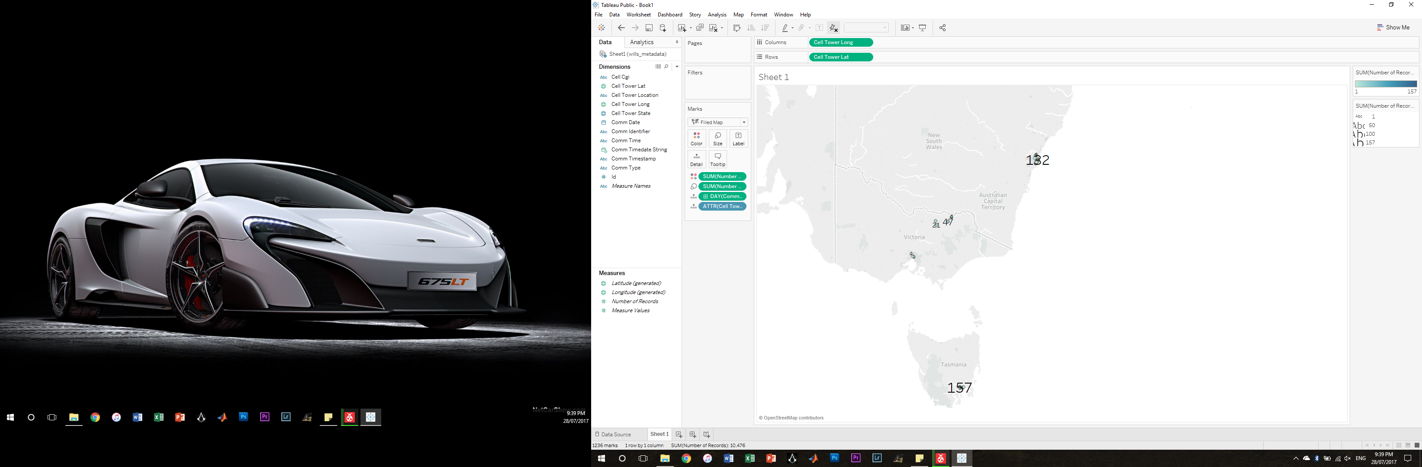The cell tower with the most activity for each day is marked 157.

**Question 3**

During the evening it can be seen that Will uses a lot more data. This is possibly because he is home by that time and just came back from work. During that time he also makes a few calls and sends SMS’s but the data is still in the majority. He also uses less data as the week goes by and on weekends the data usage is a lot less. He could be a person that loves the outdoors and leaves technology alone on weekends.

